Fiftieth CONVOCATION

Friday, 16th June 2017
Chief Guest
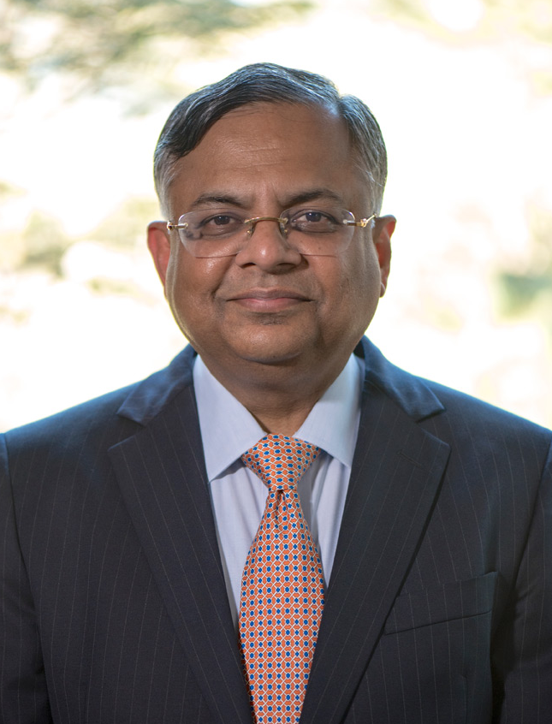
Mr. Natarajan Chandrasekaran
Chairman, TATA SONS

Mr. Natarajan Chandrasekaran is Chairman of the Board of Tata Sons, the holding company and promoter of more than 100 Tata operating companies with aggregate annual revenues of more than US$100 billion. He joined the board of Tata Sons in October 2016 and was appointed Chairman in January 2017.
Mr. Chandrasekaran also chairs the Boards of several group operating companies, including Tata Steel, Tata Motors, Tata Power, Indian Hotels and Tata Consultancy Services (TCS) - of which he was chief executive from 2009-17.
The Tata group companies include 29 publicly-listed corporations with a combined market capitalisation that exceeded US$120 billion at the start of 2017.
His appointment as Chairman followed a 30-year business career at TCS, which he joined from university. Mr. Chandrasekaran rose through the ranks at TCS to become CEO and managing director of the leading global IT solution and consulting firm.
Under his leadership, TCS generated total revenues of US$16.5 billion in 2015-16 and consolidated its position as the largest private sector employer in India and the country’s most valuable company. TCS has also been placed among the ‘Big 4’ most valuable IT services brands worldwide, ranked as one of the World’s Most Innovative Companies by Forbes and recognised as a Global Top Employer by the Top Employers Institute across 24 countries.
Mr. Chandrasekaran embedded a culture of customer-focus and innovation at TCS.
In addition to his professional career at Tata, Mr. Chandrasekaran was also appointed as a director on the board of India’s central bank, the Reserve Bank of India, in 2016. He has also served as the chairperson of the Information and Communication Technology Industry Governors at the World Economic Forum, Davos, in 2015-16.
Mr. Chandrasekaran is an active member of India’s bilateral business forums including USA, UK, Australia and Japan. He served as the chairman of NASSCOM, the apex trade body for IT services firms in India in 2012-13.
His business leadership has been recognised by several corporate and community organisations and he has received numerous awards, including:
- Business Leader of the Year at the ET Awards for Corporate Excellence 2016.
- CNBC TV 18 - ‘Indian Business Icon' 2014.
- CNN-IBN Indian of the Year 2014 (business category).
- Best CEO for 2013 and 2014 by Business Today.
- Best CEO 2010-15 Institutional Investor’s Annual All-Asia Executive Team rankings.

Mr. Chandrasekaran has been awarded several honorary doctorates by leading Indian and international universities. He attended the Regional Engineering College, Trichy, Tamil Nadu, where he completed a master’s degree in computer applications before joining TCS in 1987.
Mr. Chandrasekaran is an avid photographer and a passionate long-distance marathon runner. In April 2017 he ran the London Marathon, thereafter completing the World Marathon Majors. The World Marathon Majors include the marathons in New York, Boston, Chicago, Berlin, Tokyo and London.
Mr. Chandrasekaran born in 1963, he lives in Mumbai, with his wife Lalitha. Their son, Pranav, is at university.

